
Habib University
School of Science & Engineering
Course: | EE – 211 – Basic Electronics
Semester | Spring 2026
Assignment # | 2
Due Date : | April 14, 2026
Instructor : | Syed Arsalan Jawed
Total Marks : | 100

Instructions for Students
- Print the following question paper and provide your answer within the empty spaces given after each question.
- Keep your answers concise and to the point. Provide neat and tidy calculations and plots.
- Make reasonable assumptions related to concepts and associated parameters motivated by your text and reference book.
- Support your answer with equations where needed.

Question # 1 : [CLO-1]
Consider an NPN BJT. The junction forward bias voltage is 0.8V. You have two configurable supply voltages, which can be configured to any value between 0V and 5V. Make the BJT operate in active mode first by selecting appropriate V_{BE} and V_{CB}. Draw the NPN structure and show the connected voltage sources. Then similarly, make the BJT operate in saturation mode and share the structure and connection. Show the current flows inside the NPN structure in both cases. [20]

Question # 2 : [CLO-1]
Draw the large-signal model of the following BJT. Then convert the large-signal model into small-signal model. Ignore Early effect and derive the expression for transconductance. [20]
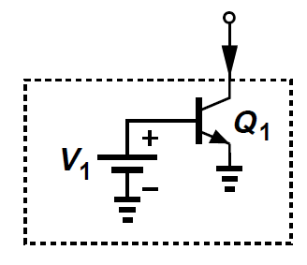

Question # 3 : [CLO2]
Q3. Derive the expression for the bias voltage at the base of the following BJT bias circuits. Compare each approach by listing one advantage and one disadvantage of each approach. [20]
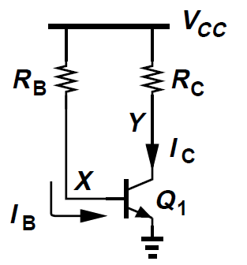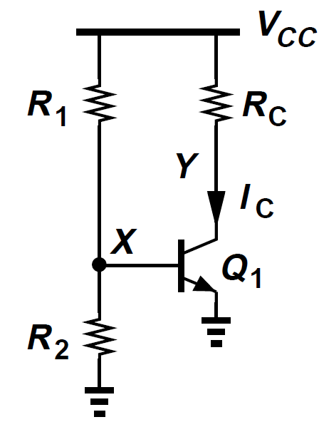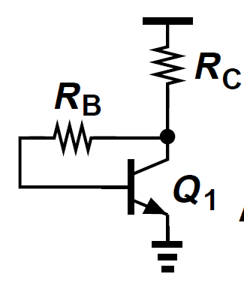

Question # 4 : [CLO-2]
Derive the expressions for small-signal voltage gain, input impedance and output impedance for the following common emitter configurations. [20]

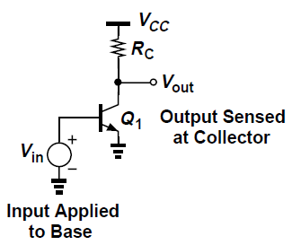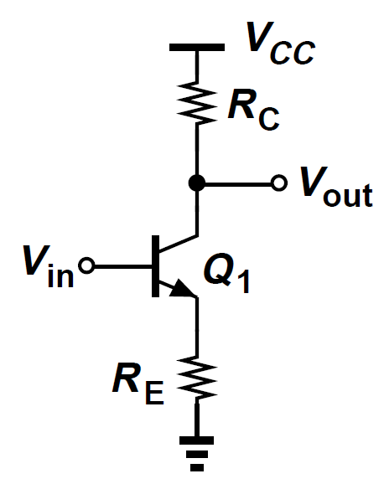

Question # 5 : [CLO-3]
Consider the following circuit where a source Vin is providing input to the BJT where Rs is the output impedance of the driving source. We need to match input impedance of the BJT with Rs=50Ω. Suggest which small-signal parameter of the BJT should be aligned to achieve matching input impedance, suggest what large-signal parameters that define the operating point should be used to achieve the required small signal parameter, give exact value of each parameter with supporting expressions. [20]
